The following article is full of errors.
Some of them are shown by a red or green line.
Other errors will have to be found by careful reading. We call this “proofreading”.
When you have found as many errors as you can ON YOUR OWN, carry out a few extra tasks
Format the heading as heading 1 and use centre align to put it into the centre
Change the font style to Comic Sans
Bullet point the list of four operations.
Add a footer and write yo name in it. Align it at the right hand margin.

COMPUTER BASICS

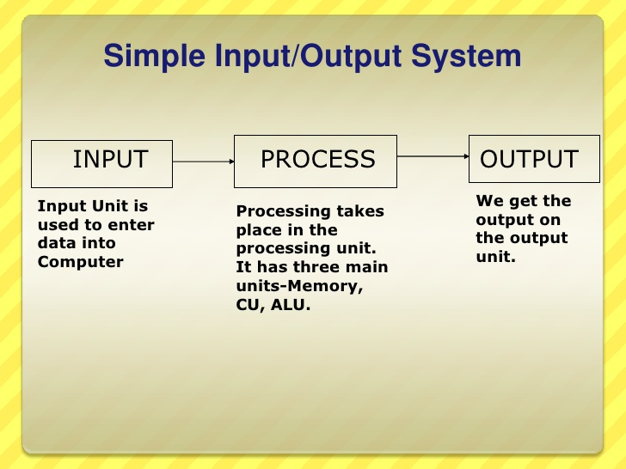
Input-Process-Output
All computers word in the same way. They have inputs witch put data into the computer. The have a processor to run the programs that process the data. Then they have the outputs witch sow you the results of the processors. http://image.slidesharecdn.com/typesandcomponentsofcomputersystem-110109113654-phpapp01/95/types-and-components-of-computer-system-12-728.jpg?cb=1294573435

Operating system
All computer have an operating system These are sum of the operations that are carried out bye the operating system:

puts things in the right place (stores data)
opens up (load) and closes down the different programs
controls the flow of data in the computer system
interprets the messages from the input devices

CPU (Processor)
The processor works incredibly fast. It is the brain of the computer. It processes the instructions of each program that is running. The speed off the processor is measured in GHz which means GigaHertz. Yew obviously want a computer with a fast processor so that it can process instructions at hi speed. Then you don’t have to wait ages for things to happen on the screen when you are playing a really exciting fame!

Hardware and Software
The parts of a computer you can touch are kalled hardwear and the programmes that you can select and run are the software.

